Data Analysis Assessment

COIT12209
Data Science

Period Covered: 27/03/2026 – 17/04/2026

April 2026

Word Count: 1932

Lachlan J. W. Wyer (12290303)

COIT12209 Lecturer and Tutor:
Mr. Arjun Neupane
Central Queensland University

Table of Contents
Introduction: 3
Question 0: Initial Development 3
Question 1: Parsing in the Clinic Data 4
Question 2: Display Number of Records and Variables 5
Question 3: Display Final 3 Rows 6
Question 4: Cleaning Data 6
Critical Vales: 6
Age: 6
Gender: 7
Cholesterol: 7
Risk Status: 7
BMI: 7
Exercise 8
General Data Changing Advice: 8
Question 5: Numerical Summary 9
Question 6: Cholesterol Histogram 11
Question 7: Age Grouping Bar Chart 13
Question 8: Distribution of Risk Status by Gender 14
Question 9: Scatter Plot 17
Question 10: Working with Health Data 17
Reflection: 18
References: 19

Table of Figures:
Figure 1 - Initial TUI that is present for decision making 3
Figure 2 - Code to create the TUI and check value of the user input 3
Figure 3 - Code that calls the correct functions based on the user’s input 4
Figure 4 - Code too import the file 4
Figure 5 - User TUI of data import 5
Figure 6 - Code for displaying number of records and variables 5
Figure 7 - TUI for showing the values 5
Figure 8 - Code for displaying final 3 rows 6
Figure 9 - User display of final 3 rows 6
Figure 10 - Code to check correct age values 6
Figure 11 - Code to delete blank gender values 7
Figure 12 - Placing all cholesterol between the acceptable values 7
Figure 13 - Dropping all values that are not risk_status values 7
Figure 14 - Absolution of the BMI values 8
Figure 15 - Absolution of negative exercise values 8
Figure 16 - Entire codebase for the data clean 8
Figure 17 - TUI for clean data function 9
Figure 18 - Code for calculating a 4 number summary for each numerical column 10
Figure 19 - Summary before clean 11
Figure 20 - Code to great the cholesterol histogram 11
Figure 21 - TUI for histogram graph 12
Figure 22 - Example cholesterol histogram 12
Figure 23 - Code to create the age groupings chart 13
Figure 24 - TUI explaining the chart is open in a new window 13
Figure 25 - Age group bar chart before data clean 14
Figure 26 - Age group bar chart after data clean 14
Figure 27 - Code to create the comparison chart of risk status 15
Figure 28 - Risk status and Gender correlation before data clean 16
Figure 29 - Risk status and gender correlations after data clean 16
Figure 30 - Code to create the Scatter Plot 17
Figure 31 - Scatter plot of Cholesterol vs Systolic BP after data clean 17

Introduction:
This project was completed with help of GitHub for a commit history as only 1 python file is to be submitted. Normally splitting these amongst different appropriately named files would help with the maintainability of the code.

Question 0: Initial Development
To make this program look a little cleaner python library OS is used to pause can clear the screen. This library is cross platform between windows and Linux and should provide a good UI for both.
When a user launches this program in the terminal, they are presented with a decision screen (Fig 1). From here, the user inputs a value presented on the screen, the system checks if it is one of the appropriate answers (Fig 2). If it is the value is parsed into a decision algorithm (Fig 3), calling the correct function based upon what the user is wishing to do.
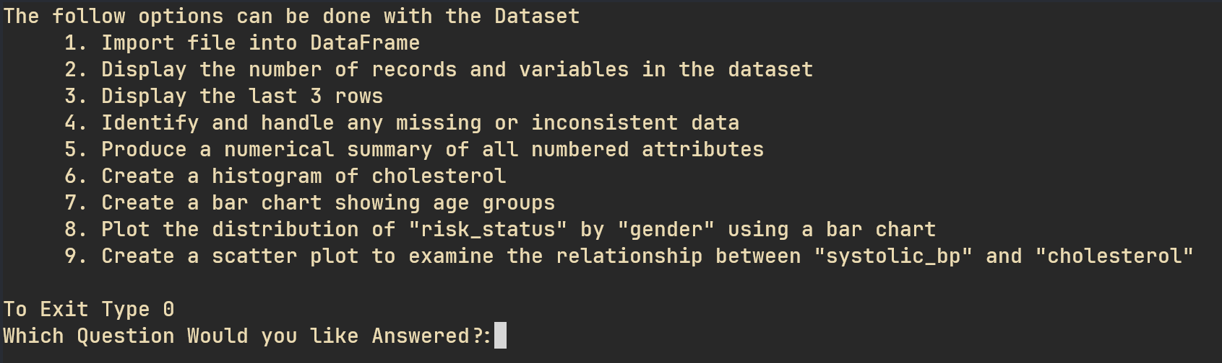
Figure 1 - Initial TUI that is present for decision making
Source - Author
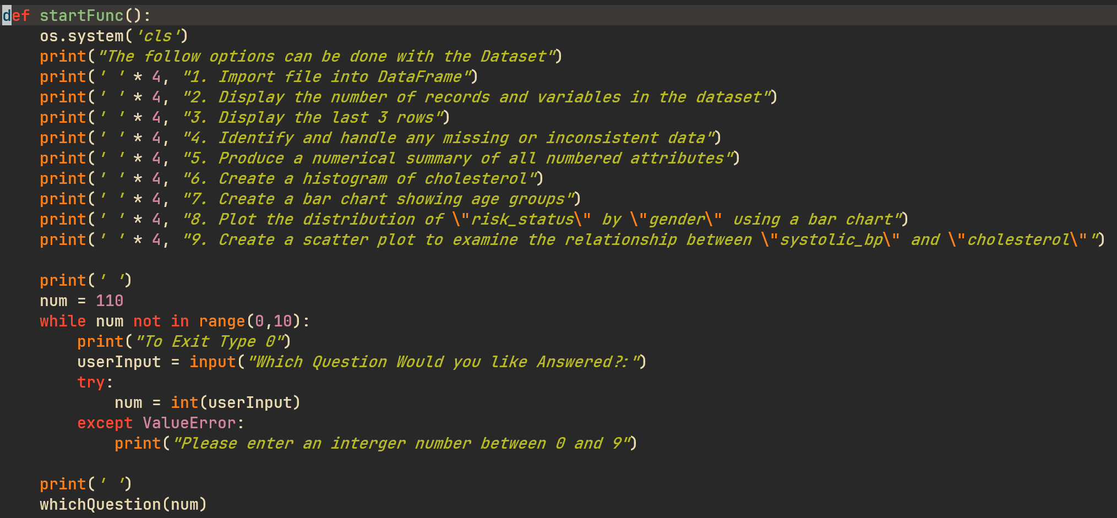
Figure 2 - Code to create the TUI and check value of the user input
Source – Author (Wyer, n.d.)
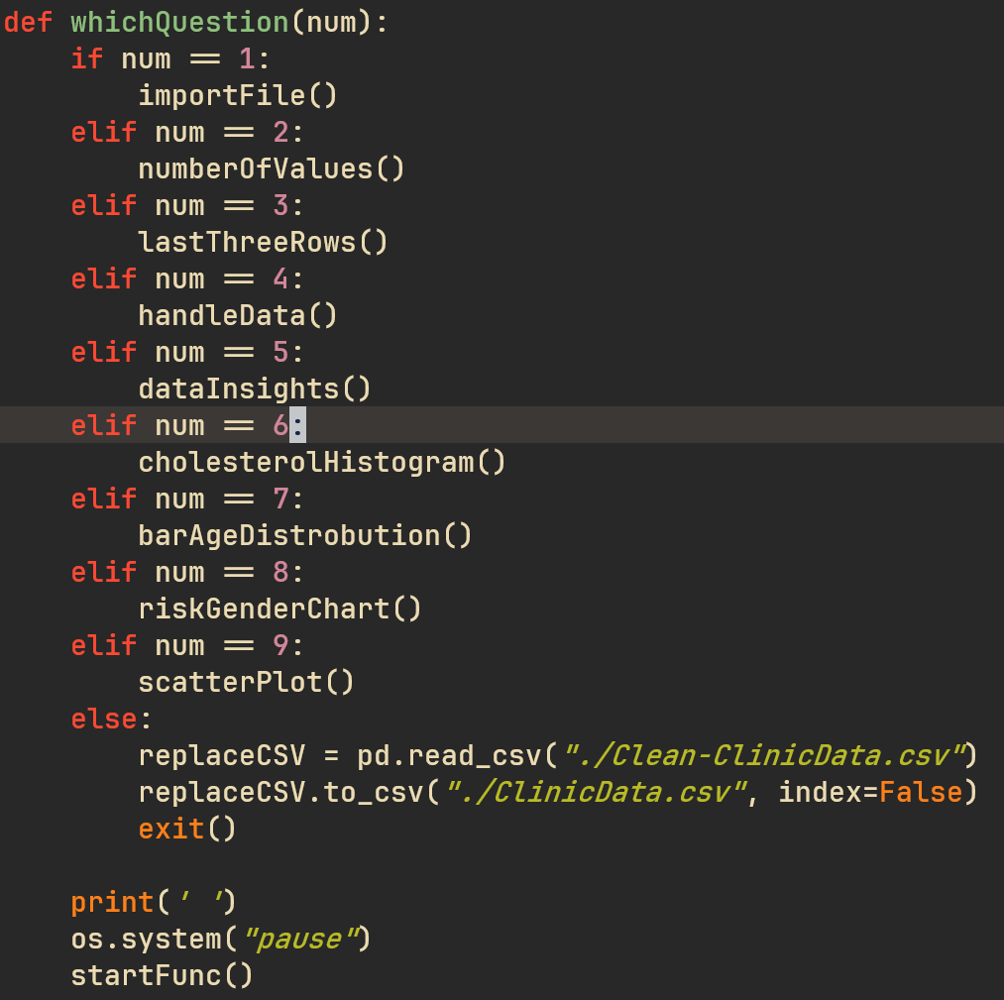
Figure 3 - Code that calls the correct functions based on the user’s input
Source – Author (Wyer, n.d.)

Question 1: Parsing in the Clinic Data
When a user input 1 for their chosen query, the data present in the CSV file is parsed into a pandas DataFrame (Fig 4). This DataFrame is then printed onto the screen, showing the raw data in the file (Fig 5).
In the comment of fileName, and fileType is the option to have the user input the file’s name and type. This allows further flexibility in the file that can be imported into the program. The only downsides are it can currently only take CSV files and assumes that the data in the file follows the same naming conventions as the original file.
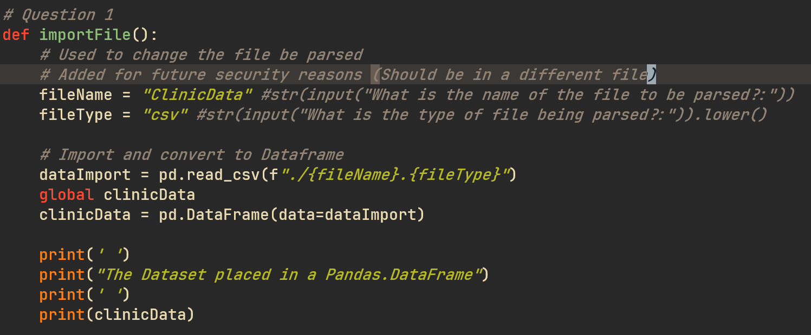
Figure 4 - Code too import the file
Source – Author (Wyer, n.d.)
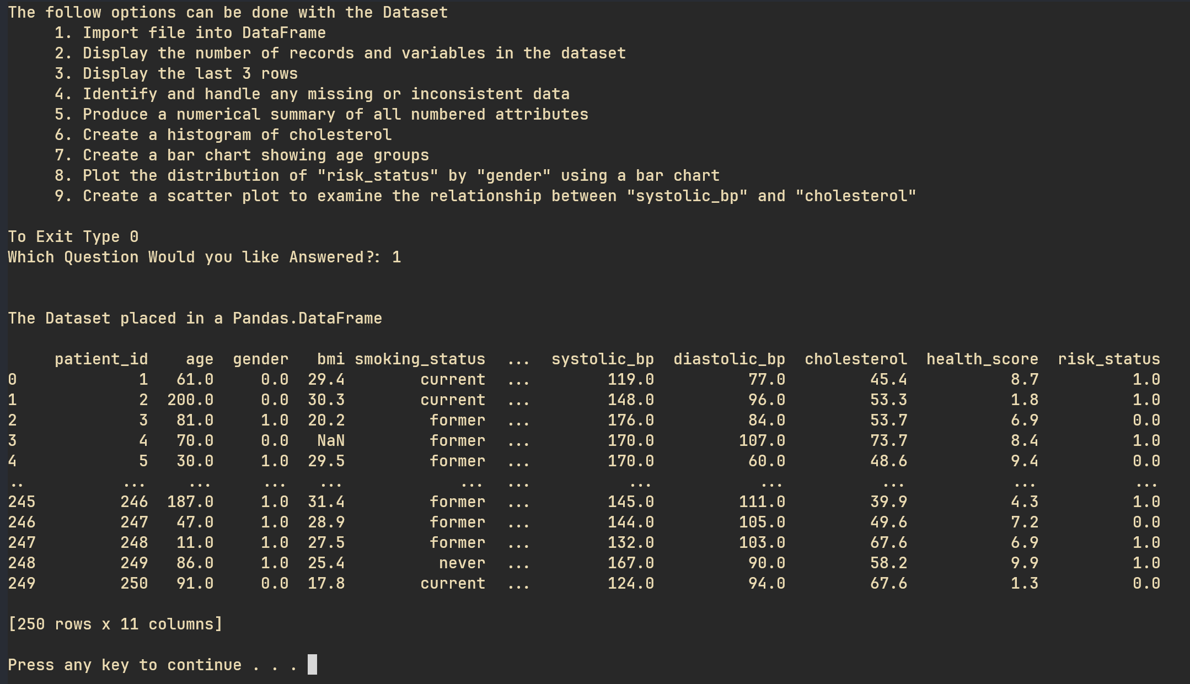
Figure 5 - User TUI of data import
Source – Author

Question 2: Display Number of Records and Variables
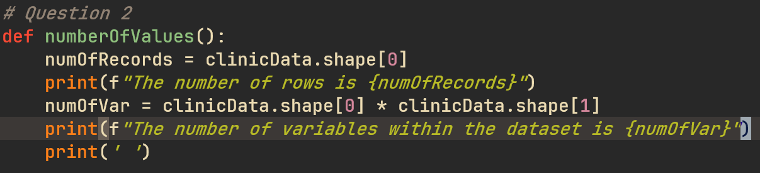
Figure 6 - Code for displaying number of records and variables
Source – Author (Wyer, n.d.)
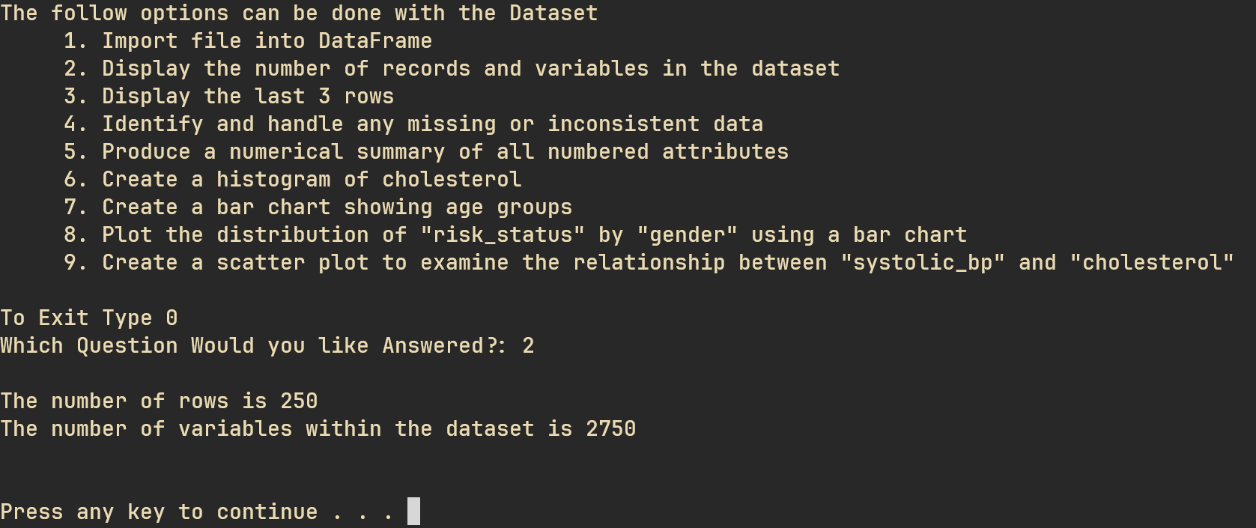
Figure 7 - TUI for showing the values
Source – Author

Question 3: Display Final 3 Rows
Uses .tail(3).
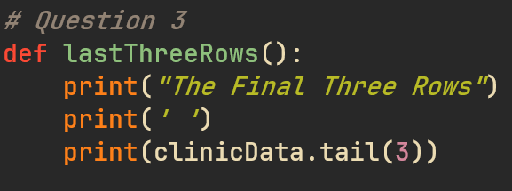
Figure 8 - Code for displaying final 3 rows
Source – Author (Wyer, n.d.)
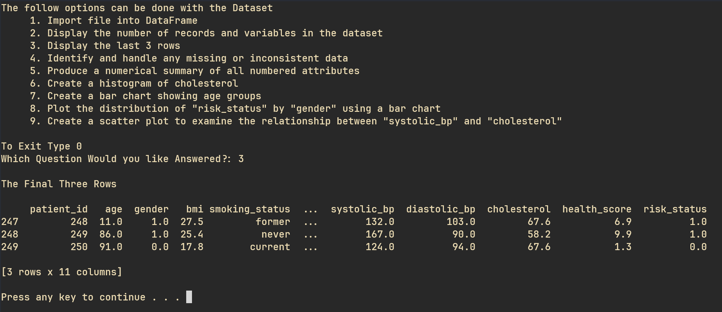
Figure 9 - User display of final 3 rows
Source – Author

Question 4: Cleaning Data
Here for each column the data was cleaned in a unique way. For critical values (age, gender, cholesterol, risk_status) a value was placed between the accepted minimum and maximum values within the dataset (Fig A). Else with the non-critical values they were just changed to 0.

Critical Vales:

Age:
Age was decided to have a maximum value of 120. This is because most the oldest people verified to have been recorded in the last century are usually close to this mark (Dale, 2025). In addition to obvious of having an age of smaller than 0 would not exist.
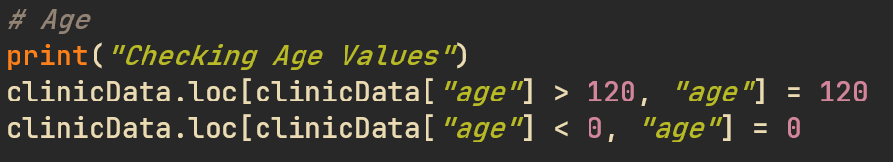
Figure 10 - Code to check correct age values
Source – Author (Wyer, n.d.)

Gender:
Gender, since there is only 1 row of data that does not have gender placed in, it was decided to remove this record from the dataset. If over half the data was missing in the column it would be easier to just redo the dataset. Since the sample of missing data is small it will not impact the entirety of the dataset that much.
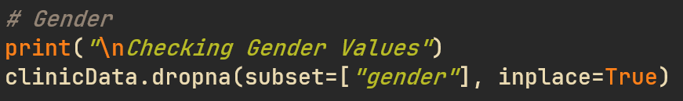
Figure 11 - Code to delete blank gender values
Source – Author (Wyer, n.d.)

Cholesterol:
Since the accepted values for the cholesterol, according to client specifications, is 0-300, everything below 0 will be change to 0 and above 300 will be 300.
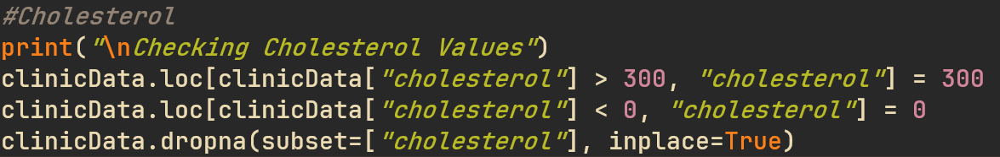
Figure 12 - Placing all cholesterol between the acceptable values
Source – Author (Wyer, n.d.)

Risk Status:
Since it was not explained how an individual’s risk status is calculated, the values outside of the 0 or 1 risk status score will be dropped.
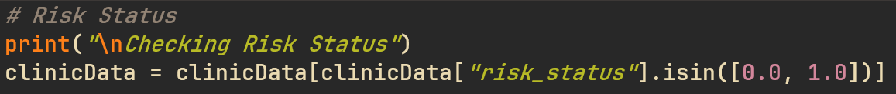
Figure 13 - Dropping all values that are not risk_status values
Source – Author (Wyer, n.d.)

BMI:
Changing the BMI to be with a range of values is incredibly difficult. This is because the range of BMI values a person can have changes with the age brackets they are within. For example, children can have a BMI of less than 0 (World Health Organization, n.d.). Whereas adults usually have an accepted minimum of 16 (World Health Organization, n.d.). As such, it will be assumed that the values themselves are correct and all negative ones will be given an absolute to be made positive.

Figure 14 - Absolution of the BMI values
Source – Author (Wyer, n.d.)

Exercise
This value is measured in the number hours that have been completed by the person. As such a negative value cannot exist. The same approach as the BMI is used here.
Figure 15 - Absolution of negative exercise values
Source – Author (Wyer, n.d.)

General Data Changing Advice:
If more time and data where present, a more complex solution of estimating a value based on existing values present within the dataset and in conjunction with a realistic value for other values present in that record.
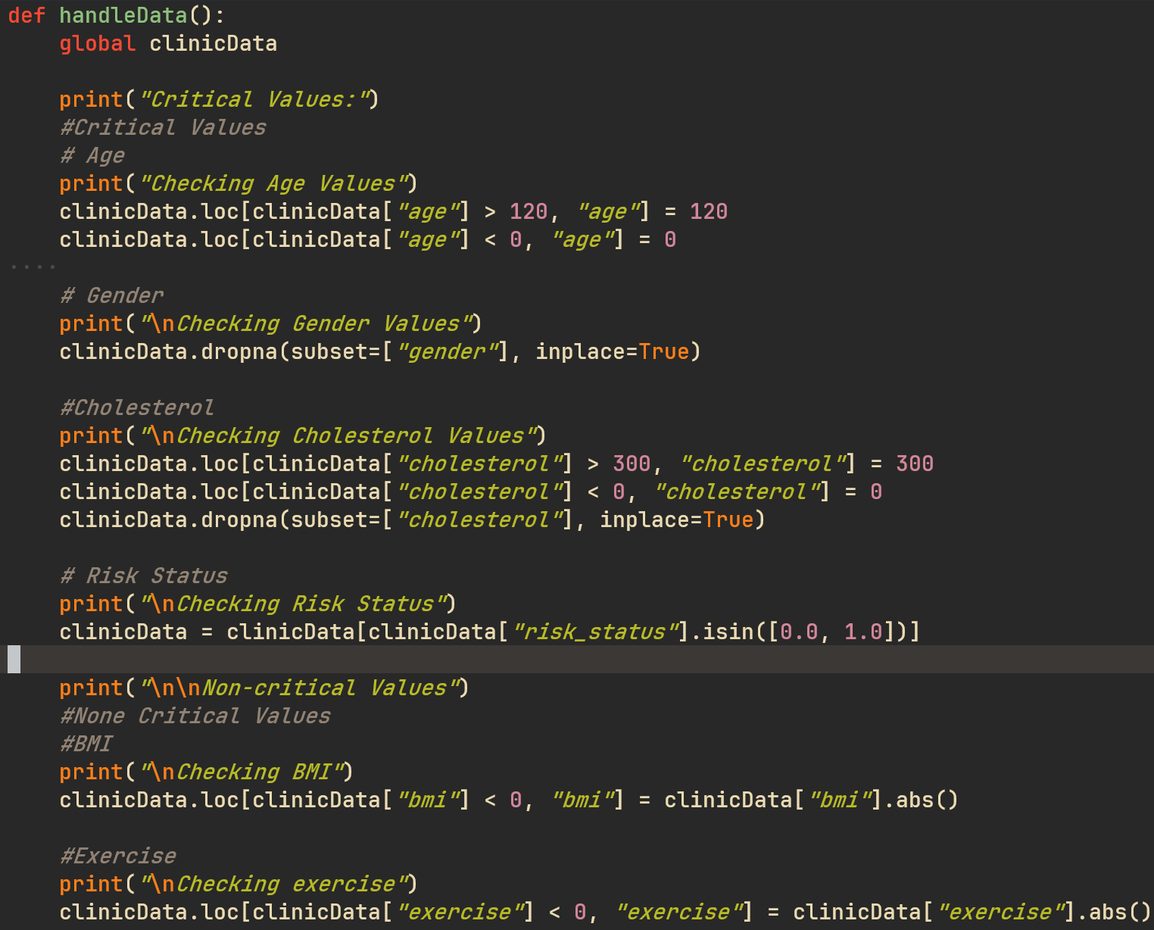
Figure 16 - Entire codebase for the data clean
Source – Author (Wyer, n.d.)
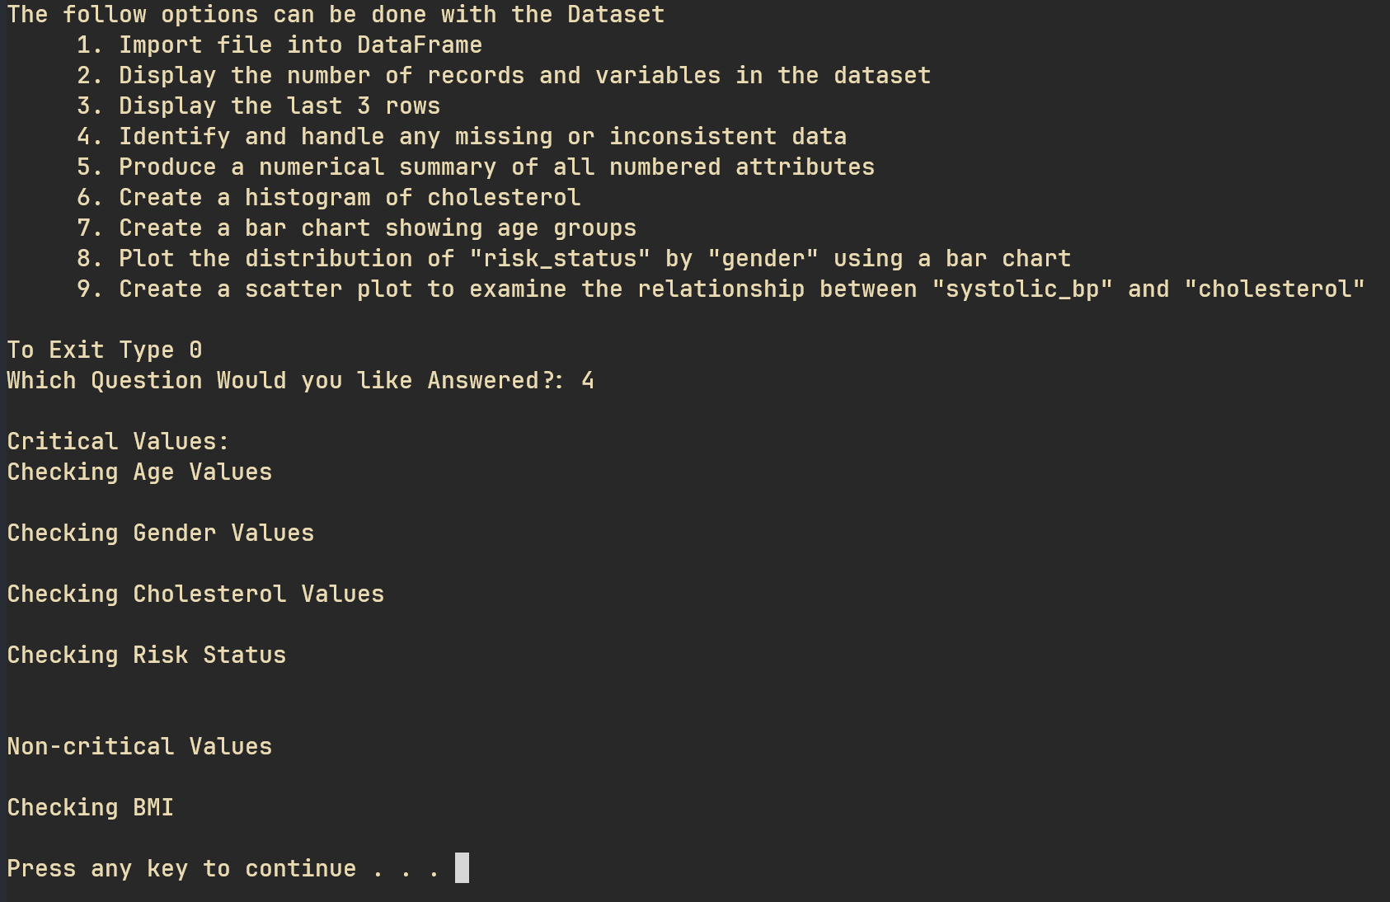
Figure 17 - TUI for clean data function
Source – Author

Question 5: Numerical Summary
A 4 number summary is a great way of gaining insight into the variety of data present within a dataset. If a user does this before cleaning the data (Fig 18) they will find a summary that contains some answer that are clearly wrong. I.E the maximum age being 200, as well as a BMI and exercise of -1.0 (Fig 19). However, this will draw out useful insights into the information presented within the database. These can include:
- Finding if there are large numbers of outliers. I.E very large maximums or very small minimums in comparison to the mean. A better way to do this would be to include the interquartile ranges (E.g. traditional 5 number summary). Further defining outliers within the dataset.
- Determining the weakest, strongest and average of the human health within the clinic Data provided.
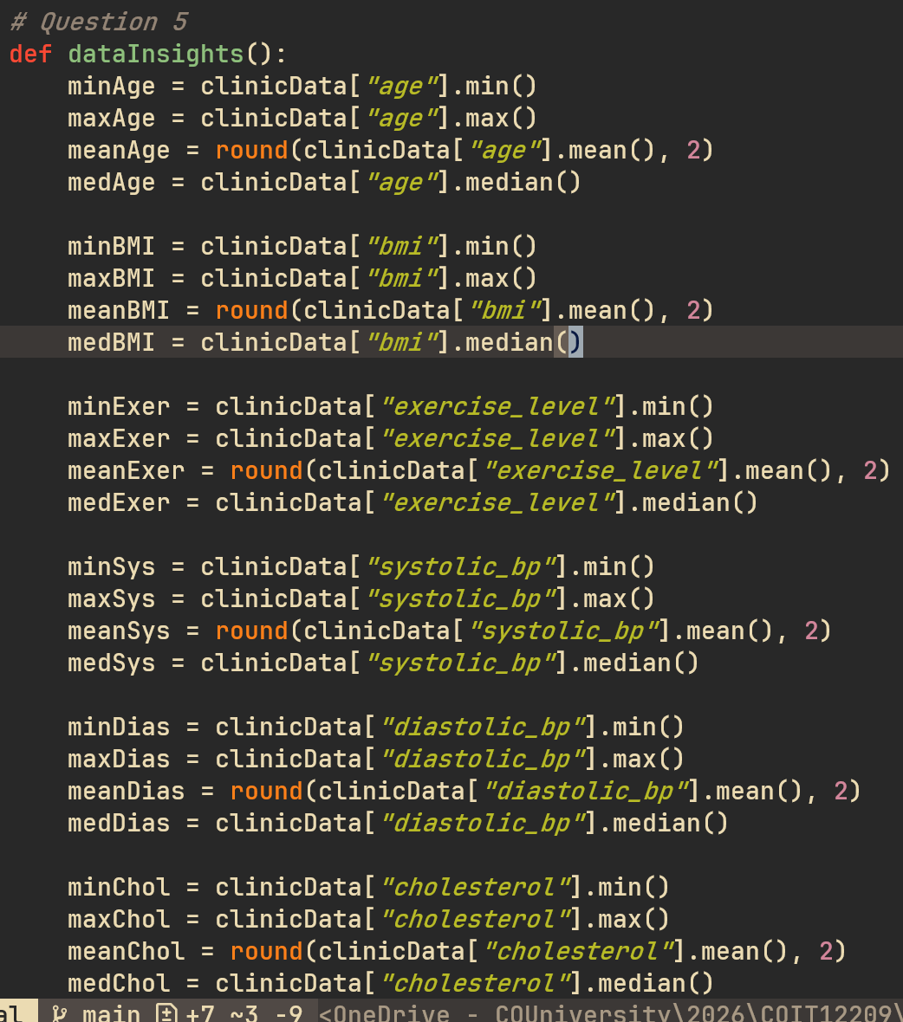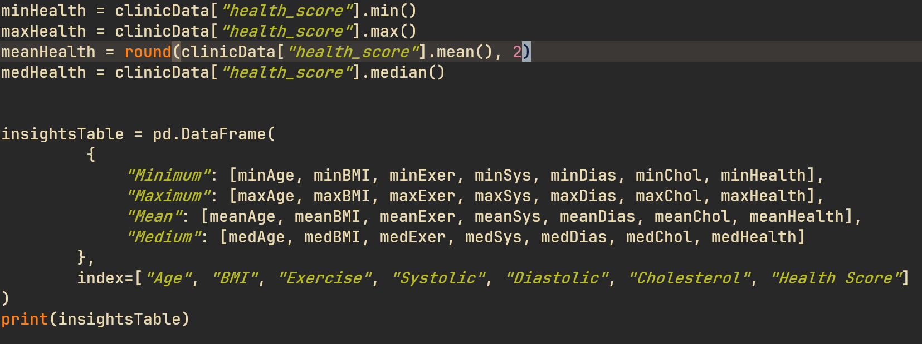
Figure 18 - Code for calculating a 4 number summary for each numerical column
Source – Author (Wyer, n.d.)
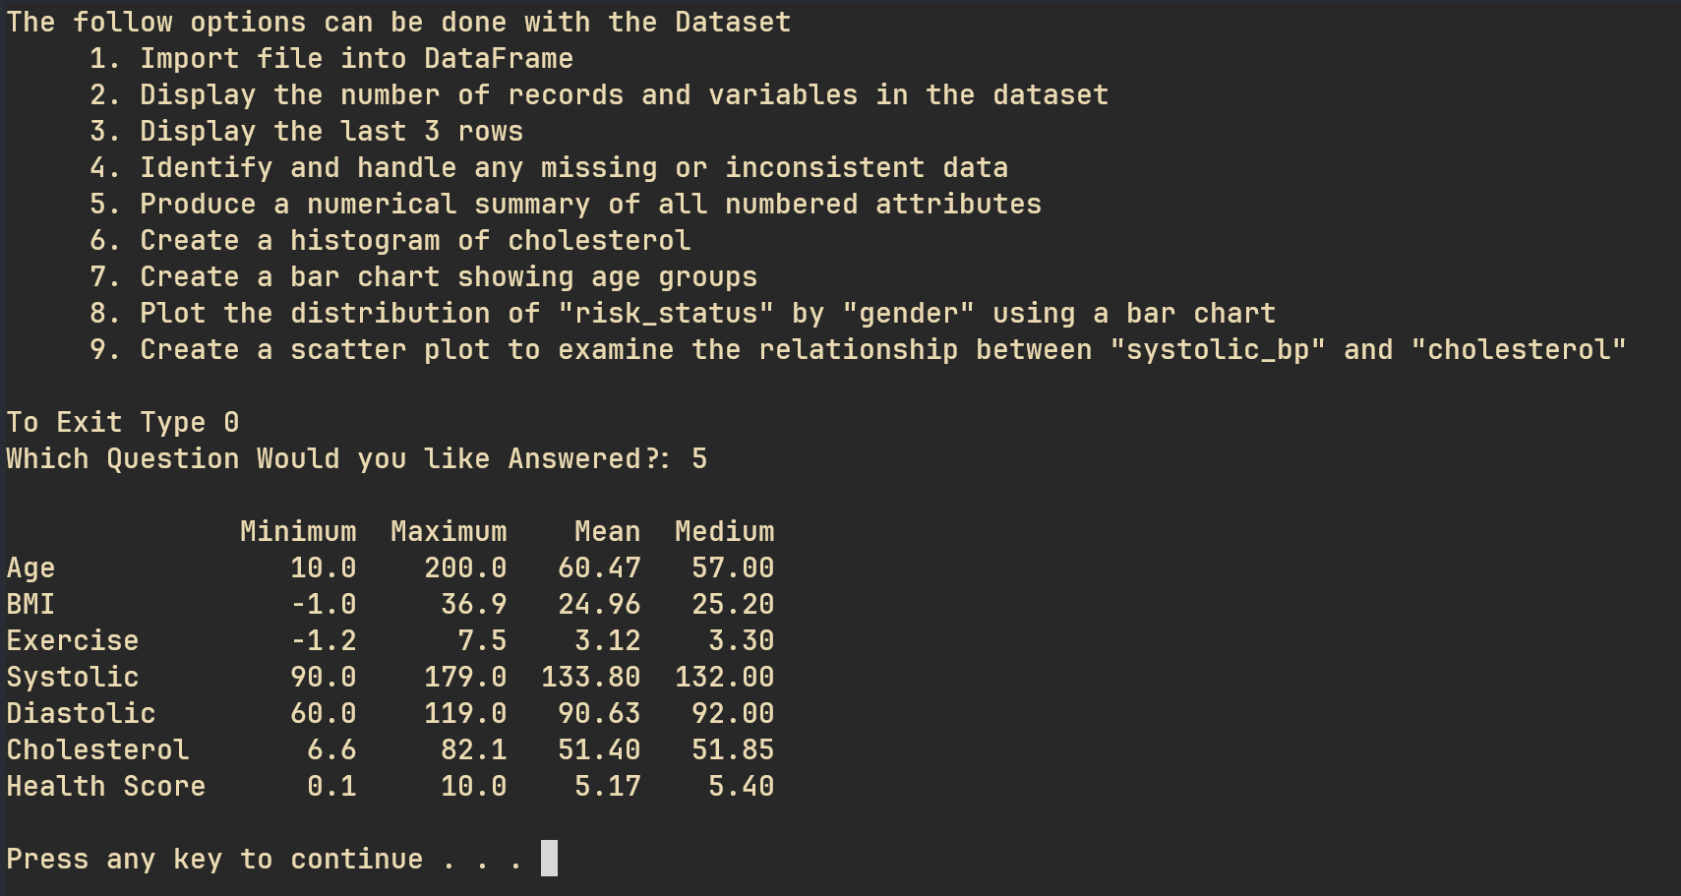
Figure 19 - Summary before clean
Source – Author

Question 6: Cholesterol Histogram
The frequency distribution in the cholesterol histogram can change widely with the number of bins that the developer wishes to include. The more bins the more bars and accurate the chart becomes. Here 20 bins were chosen as a middle ground between efficiency and accuracy.
As shown in Figure 22 the histogram appears to be normally distributed with the greatest number of people grouping around the 50 mark and failing off either side towards 0 frequency.
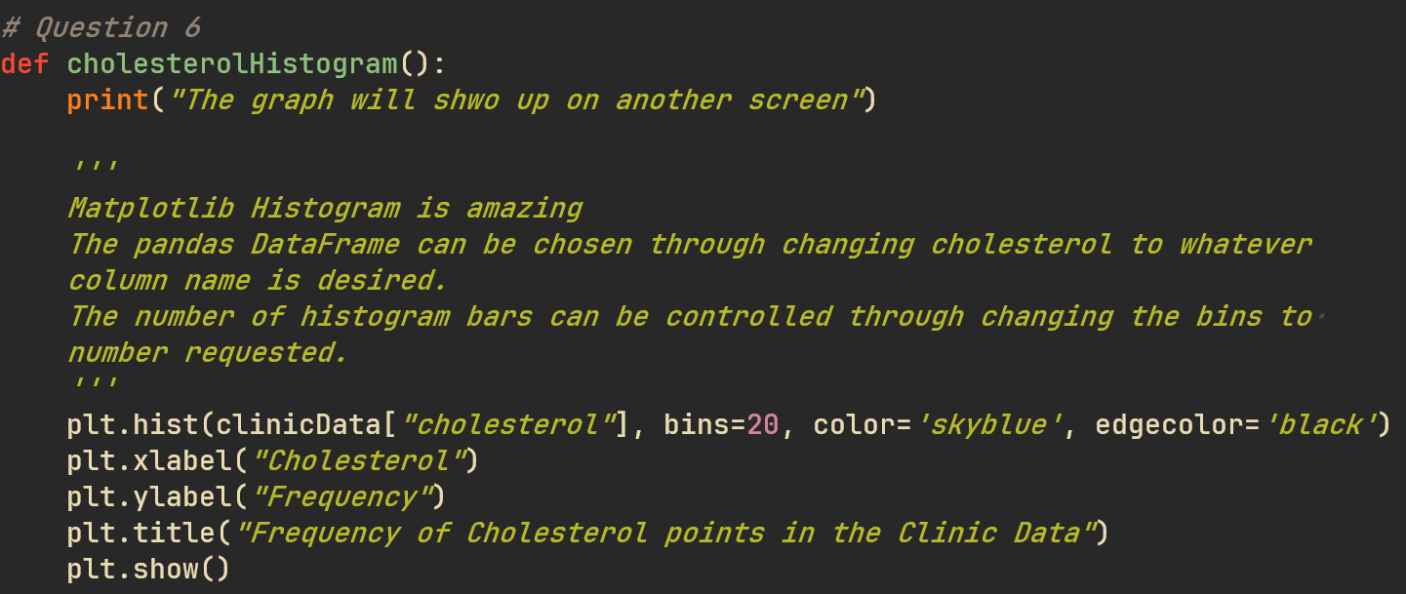
Figure 20 - Code to great the cholesterol histogram
Source – Author (Wyer, n.d.)
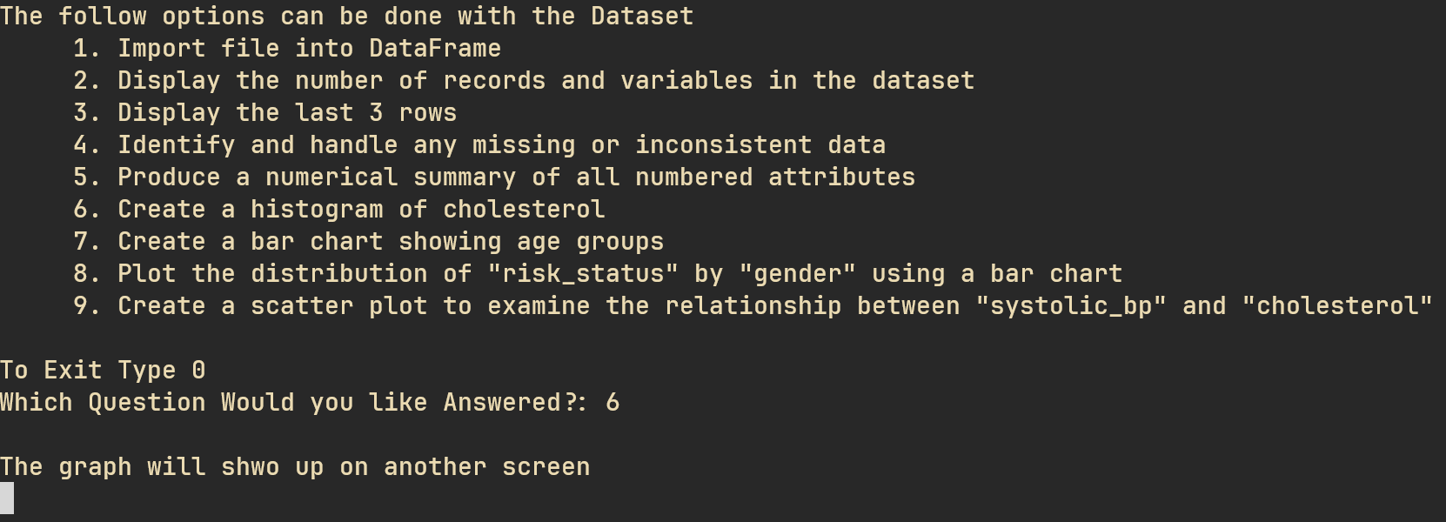
Figure 21 - TUI for histogram graph
Source - Author
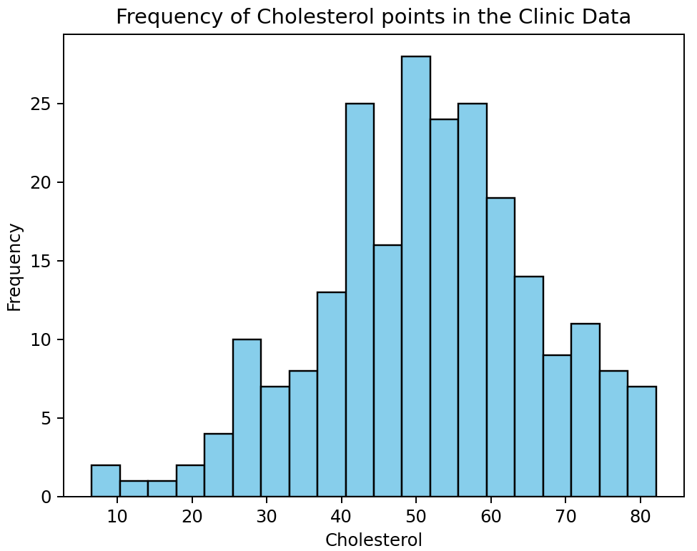
Figure 22 - Example cholesterol histogram
Source - Author

Question 7: Age Grouping Bar Chart
There is an extra grouping for people who forgot to clean the dataset before creating the graph. As even in the test dataset there is a record that do not contain an age. This just creates a visual direction in which the user can see any errors within the data (Fig 25). If all data is correct the “No Age Entered” column will have some values within it (Fig 26).
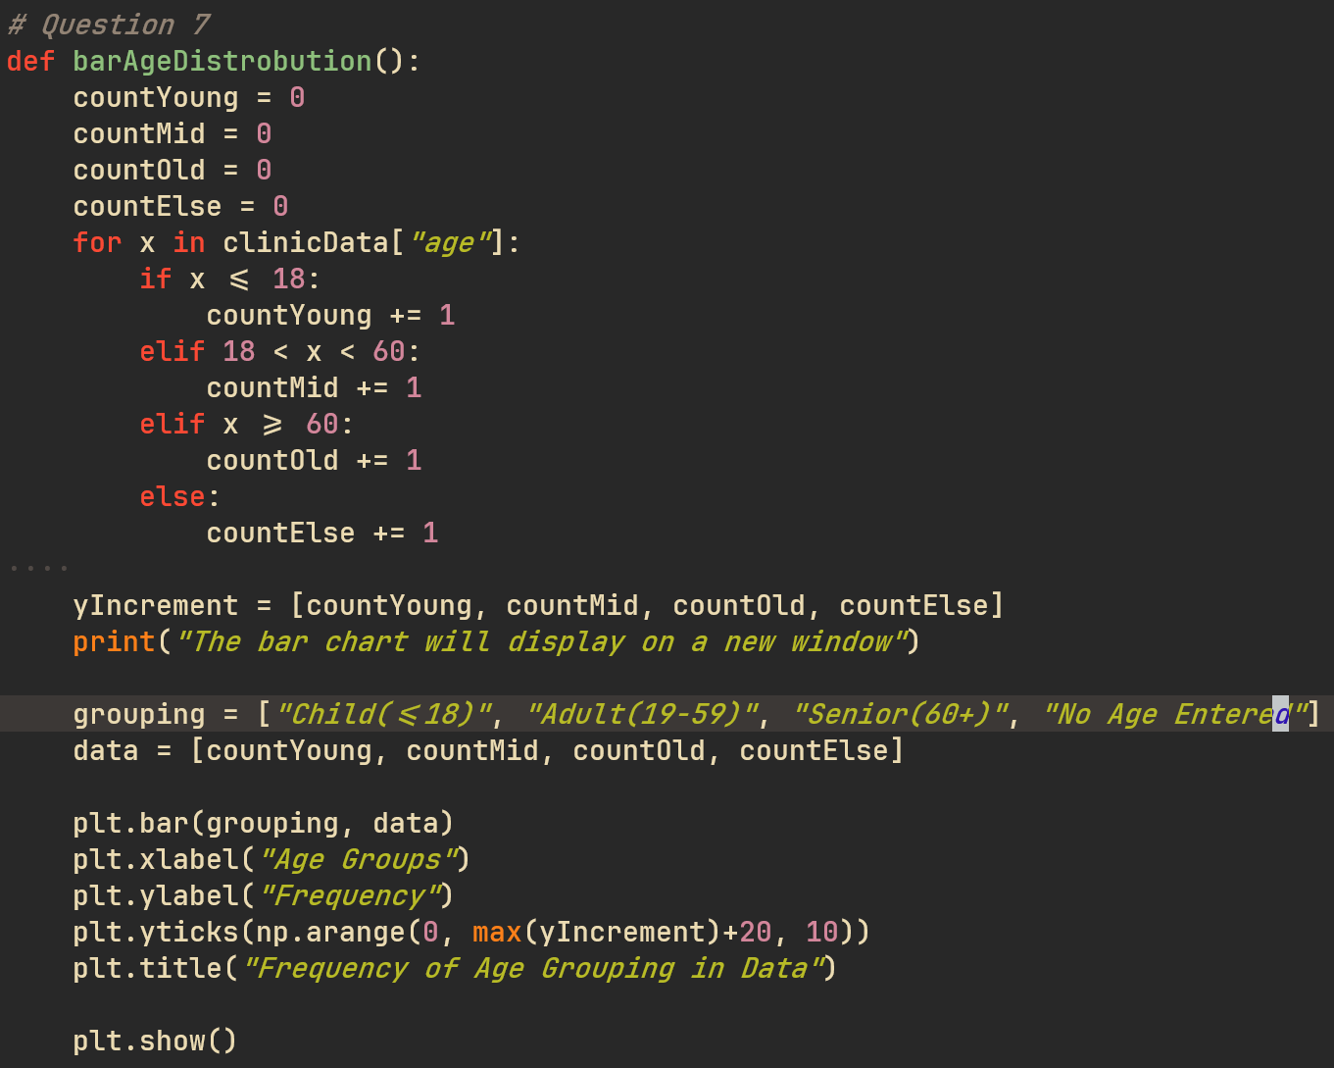
Figure 23 - Code to create the age groupings chart
Source – Author (Wyer, n.d.)
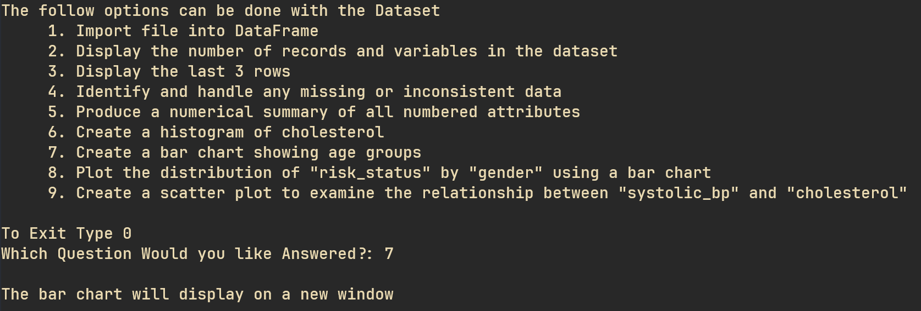
Figure 24 - TUI explaining the chart is open in a new window
Source – Author

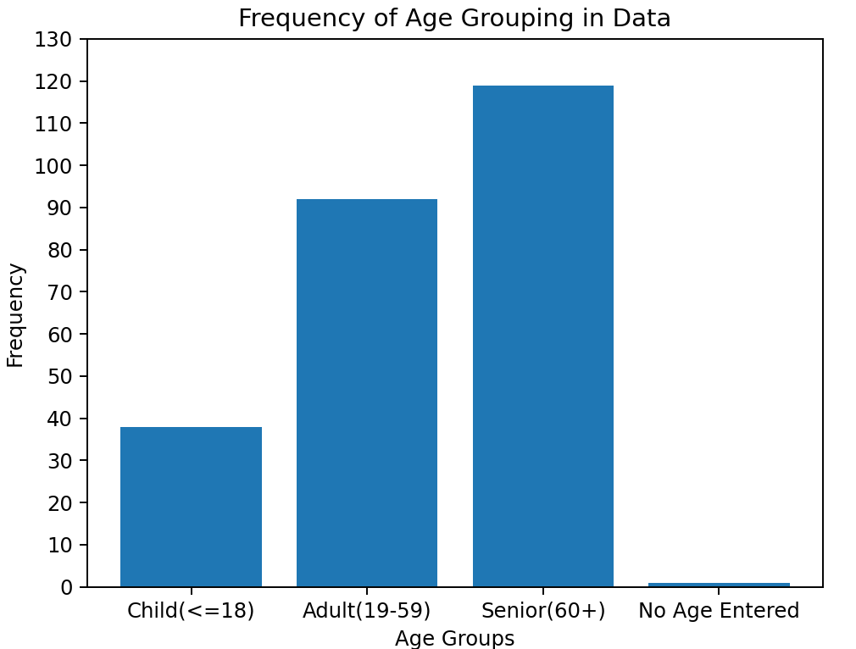
Figure 25 - Age group bar chart before data clean
Source – Author
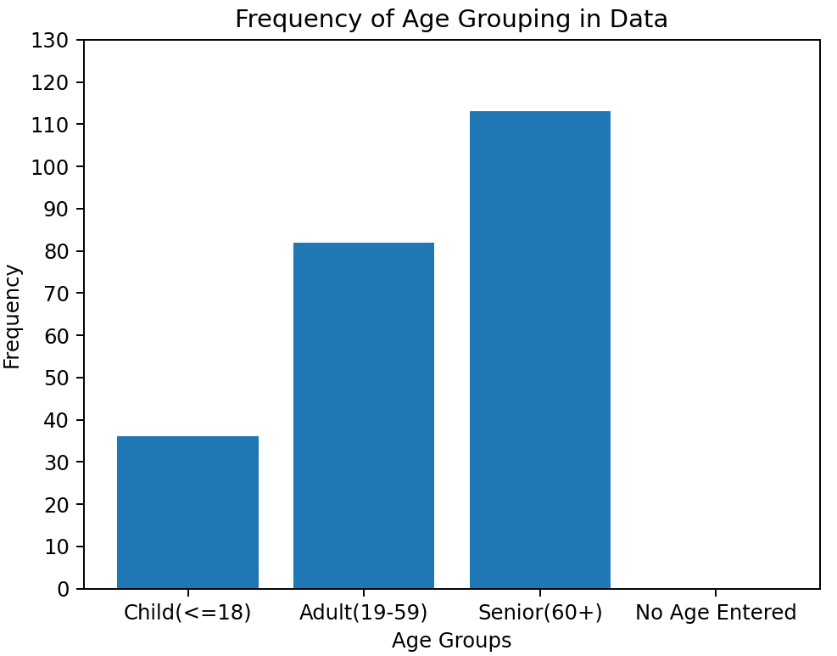
Figure 26 - Age group bar chart after data clean
Source – Author

Question 8: Distribution of Risk Status by Gender
The error column is included as the clean data is not done automatically. As in the user must input a 4 value in the selection process before the data is cleaned. This creates a visual cue that a person can look at the data and see that it is incorrect (Fig 28). However, a more accurate representation can be found once the data has been cleaned (Fig 29).
Analysis from the data will be conducted on the cleaned dataset (Fig 29). From this is can be shown that men are more at cardiovascular risk then women. With gap of the low risk being ~20 women more than men. However, of the whole group ~52% of people are considered to be at high cardiovascular risk.
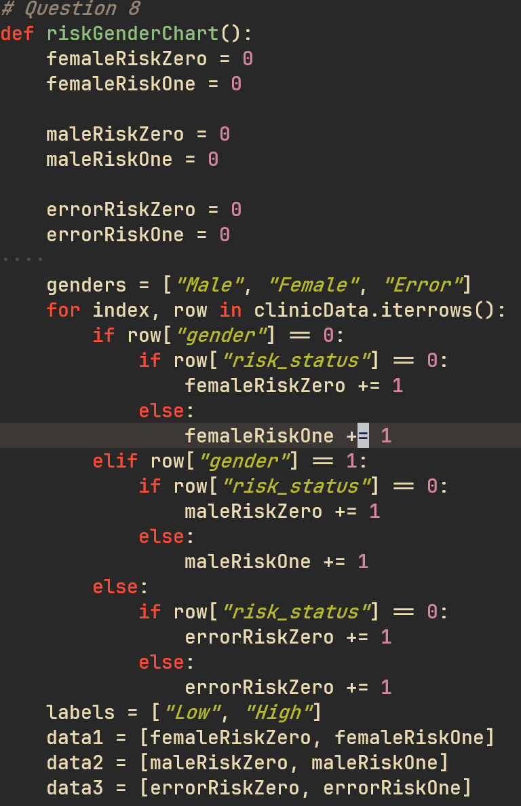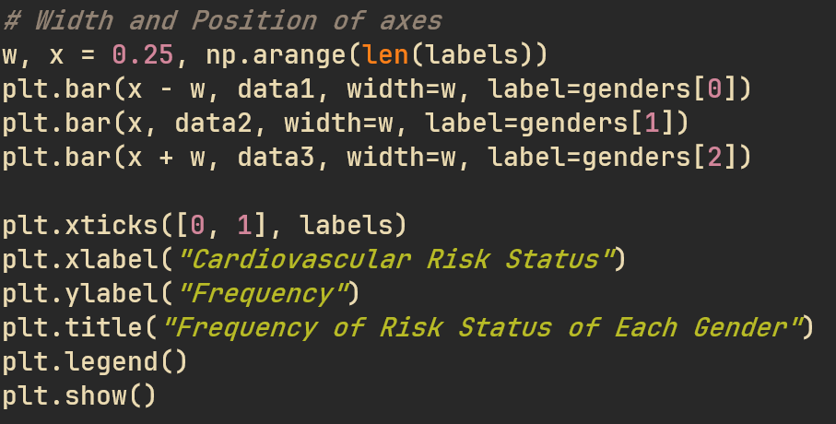
Figure 27 - Code to create the comparison chart of risk status
Source – Author (Wyer, n.d.)
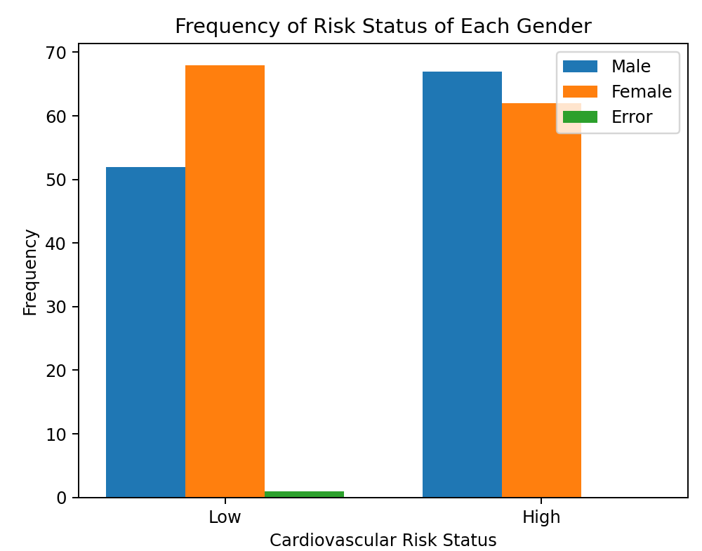
Figure 28 - Risk status and Gender correlation before data clean
Source – Author
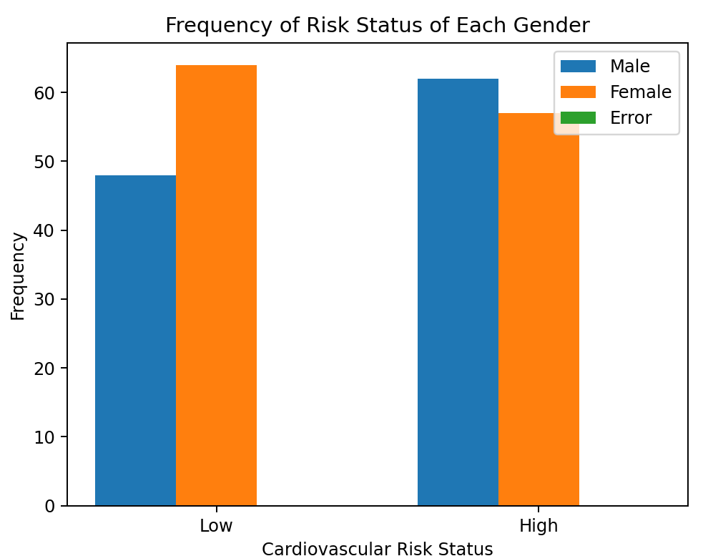
Figure 29 - Risk status and gender correlations after data clean
Source – Author

Question 9: Scatter Plot
The expected outcome of scatter plot was not found within this dataset. That is, as cholesterol increases the systolic BP of person should also increase (American Heart Foundation, 2026). The actual outcome within the dataset was that there is a random correlation between a person’s cholesterol and their systolic BP. The average cholesterol can be seen hovering around the 50 mark.
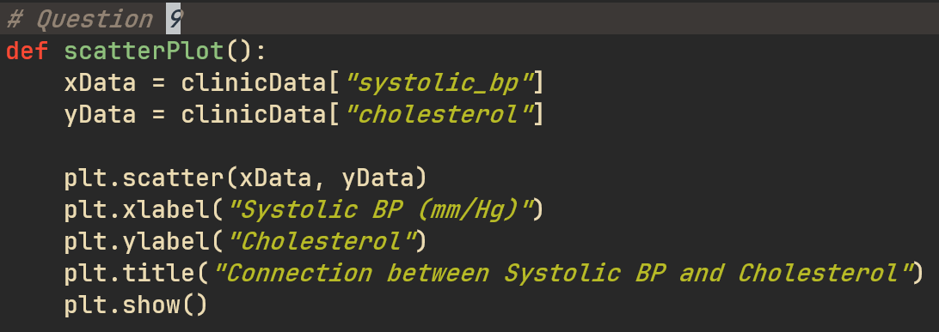
Figure 30 - Code to create the Scatter Plot
Source – Author
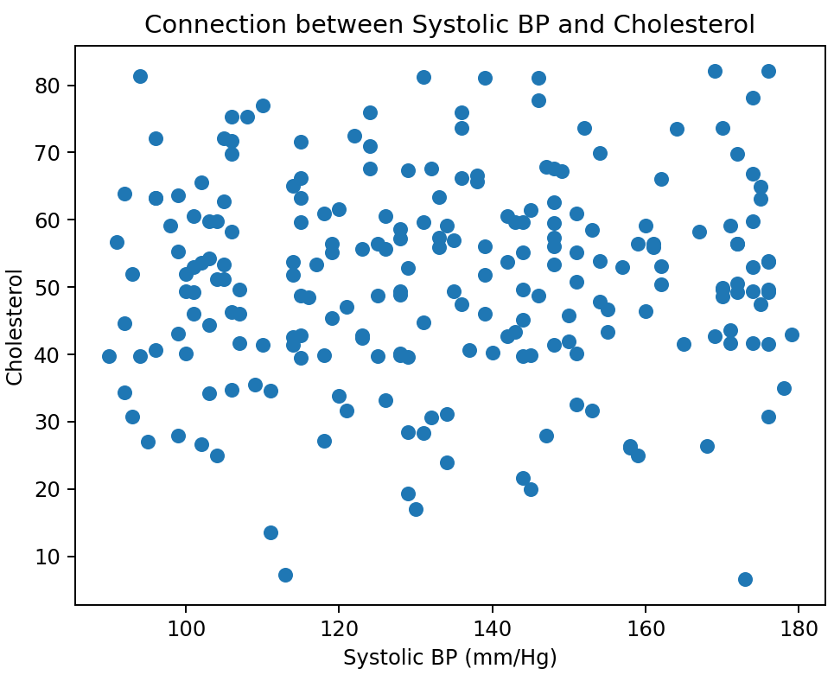
Figure 31 - Scatter plot of Cholesterol vs Systolic BP after data clean
Source – Author

Question 10: Working with Health Data
When working with and around any health data there are numerous privacy concerns. Even with anonymised data, there can be enough identifiable information within a record that linked with other datasets can uniquely identify the person inside. As such the utmost care should be taken when accessing, transporting or utilizing the data. The most obvious way is long, randomized passwords and strong encryption keys like AES 512. In addition to making sure that the consent of everyone’s data being used in this way understanding the privacy risks taken when this will inevitably be leaked/hacked in some way.
If this data is being utilized as training data, I.E a machine learning algorithm to predict results based on data inputs, the biasing within the data must be considered. For example, using a population dataset based on white middle-aged men, and using it with old Chinese women there would be a clear representation, sampling and confirmation bias towards the issues presented within the dataset. As such the baseline within the dataset must be representative of the population that data will be applied too. E.g. for a general medical algorithm, getting as many as points from as variable population as possible.

Reflection:
Throughout the process of creating this report there were numerous items learnt. These include the ability to understand the technical API pandas (pandas, n.d.) and matplotlib (matplotlib, n.d.) documentation. This is an important process as you can then apply the knowledge knowing that the information is coming from a primary source and matching to the correct version that is installed locally (I.E pandas removing and changing different API calls within the library versions). Once this skill is learnt, it is quite easy to apply this to other types of software documentation (E.g. matplotlib, seaborn, python 3.13, git). More personal skills that were honed throughout this task are NeoVim’s 3 different modes (Normal, Insert and Visual) for movement and remembering and practicing keyboard inputs and macros (“neovim/neovim,” 2026). As well as creating custom keyboard shortcuts within Neovim for launching the python program within a terminal window and git integrations for commit history. Leading into the final skill learnt is the git commit process (git add ., git commit -m “Commit message” and git push) (Linux Foundation, n.d.). A useful skill to learn as this open-source program is used everywhere within the programming industry for commit history, rollback functions and group collaboration. As well as being able to keep up to date with different version of the program in different branches. Thus, throughout the course of completing this report, several different items were learnt.

References:
American Heart Foundation, 2026. What Is Cholesterol? [WWW Document]. www.heart.org. URL https://www.heart.org/en/health-topics/cholesterol/about-cholesterol (accessed 4.6.26).
Dale, B., 2025. Ethel Caterham, world’s oldest living person, marks 116th birthday. BBC.
Linux Foundation, n.d. Git - Reference [WWW Document]. URL https://git-scm.com/docs (accessed 4.8.26).
matplotlib, n.d. API Reference — Matplotlib 3.10.8 documentation [WWW Document]. URL https://matplotlib.org/stable/api/index.html (accessed 4.8.26).
neovim/neovim, 2026. https://github.com/neovim/neovim
pandas, n.d. DataFrame — pandas 3.0.2 documentation [WWW Document]. URL https://pandas.pydata.org/pandas-docs/stable/reference/frame.html (accessed 4.8.26).
World Health Organization, n.d. Thinness among children and adolescents, BMI < -2 standard deviations below the median, prevalence (crude estimate) (%).
World Health Organization, n.d. Underweight among adults, BMI < 18.5, prevalence (age-standardized estimate) (%).
Wyer, L., n.d. Python-Pandas. https://github.com/BayElectrician/Python-Pandas

